Chapter 12 Summary

**What is Communication?**

Communication is simply the act of transferring information from one place, person or group to another. Every communication involves (at least) one sender, a message and a recipient.

These include our emotions, the cultural situation, the medium used to communicate, and even our location.

**Interpersonal Communication**

* + - Communication between two or more people.

**Organisational Communication**

* + - All the patterns, network, and systems of communications within an organization.

**Four functions of Communication**

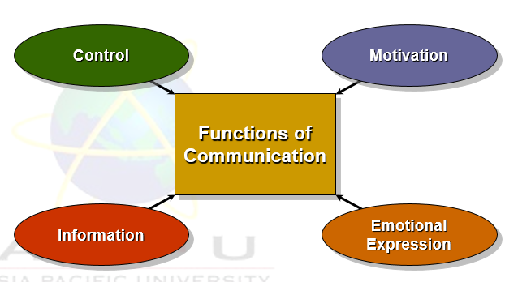

**Control**

* **Taking charge and ensuring all things are in order**
* Formal and informal communications act to control individuals’ behaviors in organizations.

**Motivation**

* **Provides encouragement and positive feedback.**
* Communications clarify for employees what is to done, how well they have done it, and what can be done to improve performance.

**Informational**

* **Looks at the information that is being made available for the respective individuals**
* Individuals and work groups need information to make decisions or to do their work.

**Emotional Expression**

* **Looks at the feelings and how do people and individuals feel**
* Social interaction in the form of work group communications provides a way for employees to express themselves.

**The Interpersonal Communication Process**

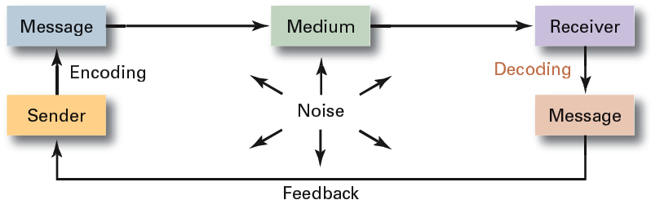

* Message
  + Source: sender’s intended meaning
* Encoding
  + The message converted to symbolic form
* Channel
  + The medium through which the message travels
* Decoding
  + The receiver’s retranslation of the message
* Noise
  + Disturbances that interfere with communications

**Active Listening**

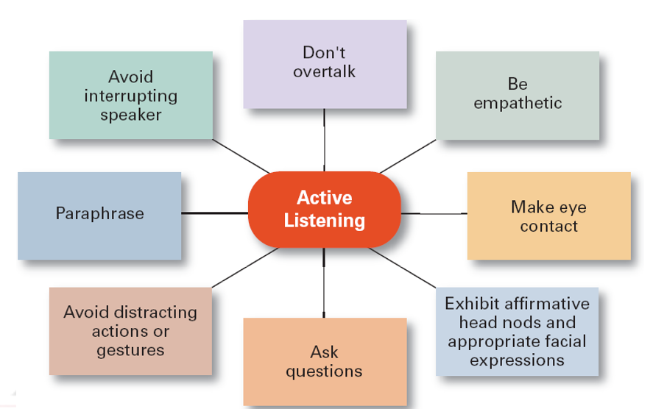

**Don’t over talk**

* When passing a message to a person, try to inform them slowly in order for the listener to understand what was being mentioned by the speaker. At the same time, the listener should refrain from speaking while the other party is speaking.

**Be empathetic**

* Empathetic refers to expressing something forcibly and clearly. All message told should be clear and precise in order for the listener to understand.

**Make eye contact**

* Eye contact is very important to ensure that the message is intended for that individual. Eye contact also means that the person is observing and looking at the speaker.

**Exhibit affirmative head nods and appropriate facial expressions**

* Showing this means that the listener is acknowledging what is being spoken by the other person and to indicate that they are following.

**Ask questions**

* If there are doubts or issues, the listener can ask questions in order to clear the doubt and clarify the issue that is being mentioned.

**Avoid distracting actions or gestures**

* Do not have too much movements and actions as this can be quite distracting for the listener to understand.

**Paraphrase**

* This means that the message or content is being reworded to an easier understanding that the listener could understand based on what the speaker is speaking about.

**Avoid interrupting the speaker**

* Do not interrupt the speaker till he or she has finished speak in order to avoid disrupting the flow of the message that is intended to be passed to the listener.